2.)

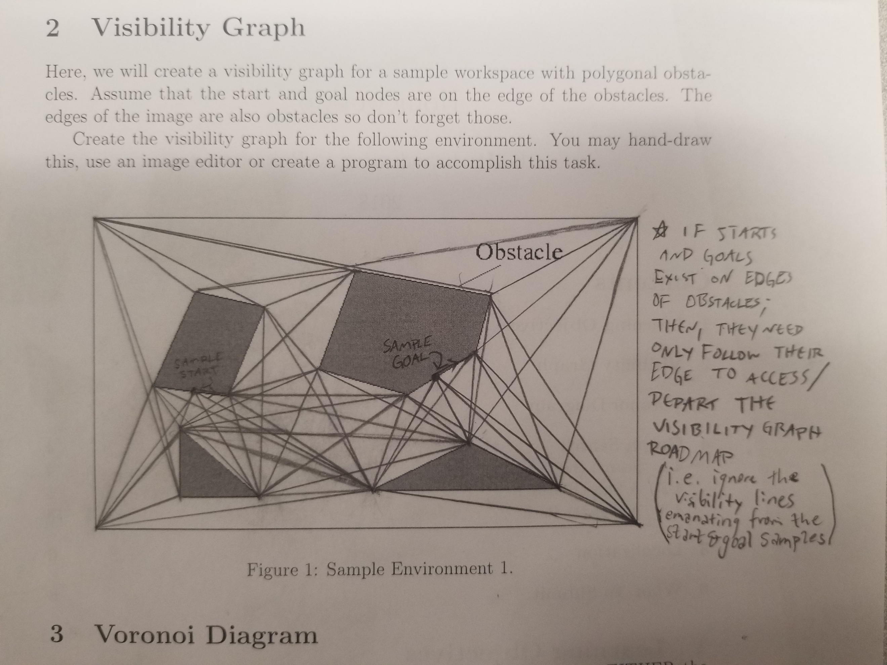

3.)

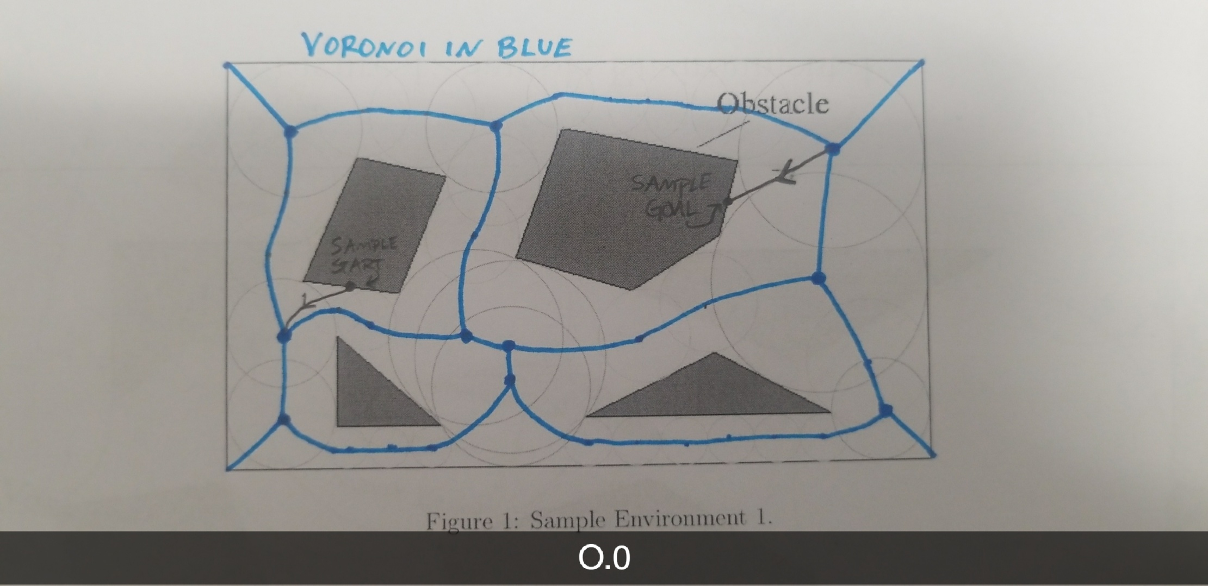

4.)

1. Search the Graph:

**BFS:**

**DFS:**

2. A Short Path?

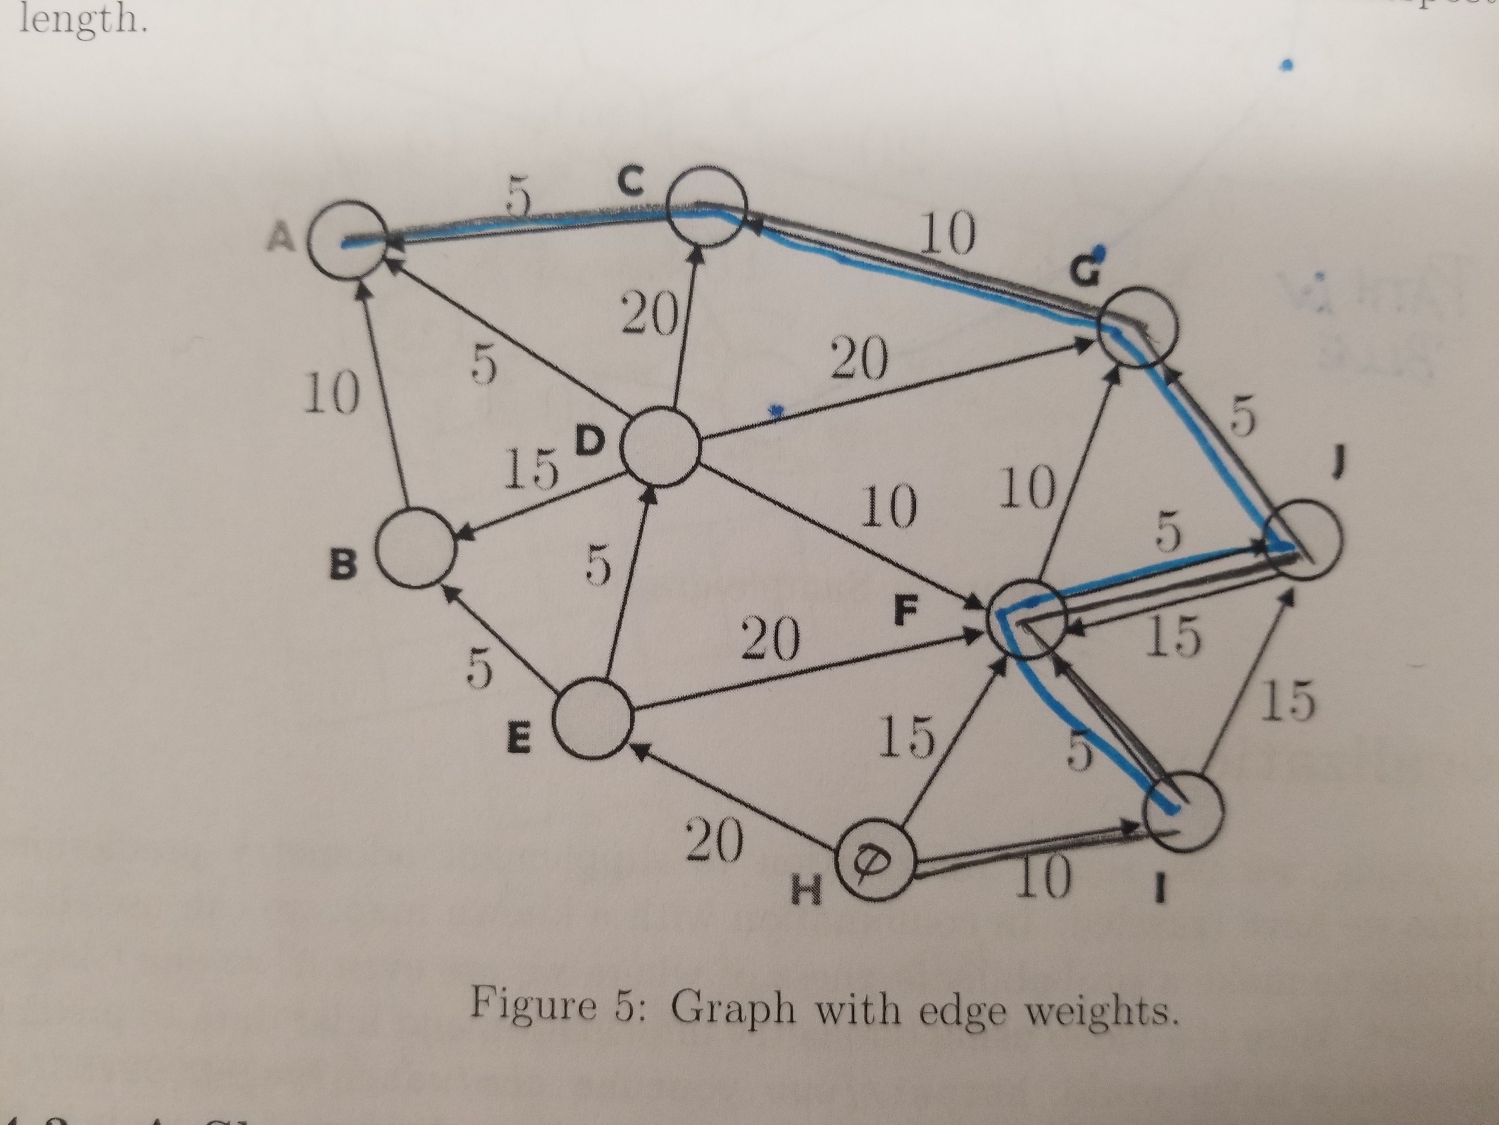

3. A Shorter Path

Ordered List of Expanded Nodes (Closed List): $\left\{H,E,F,I,G,B,J,A\right\}$

Path:

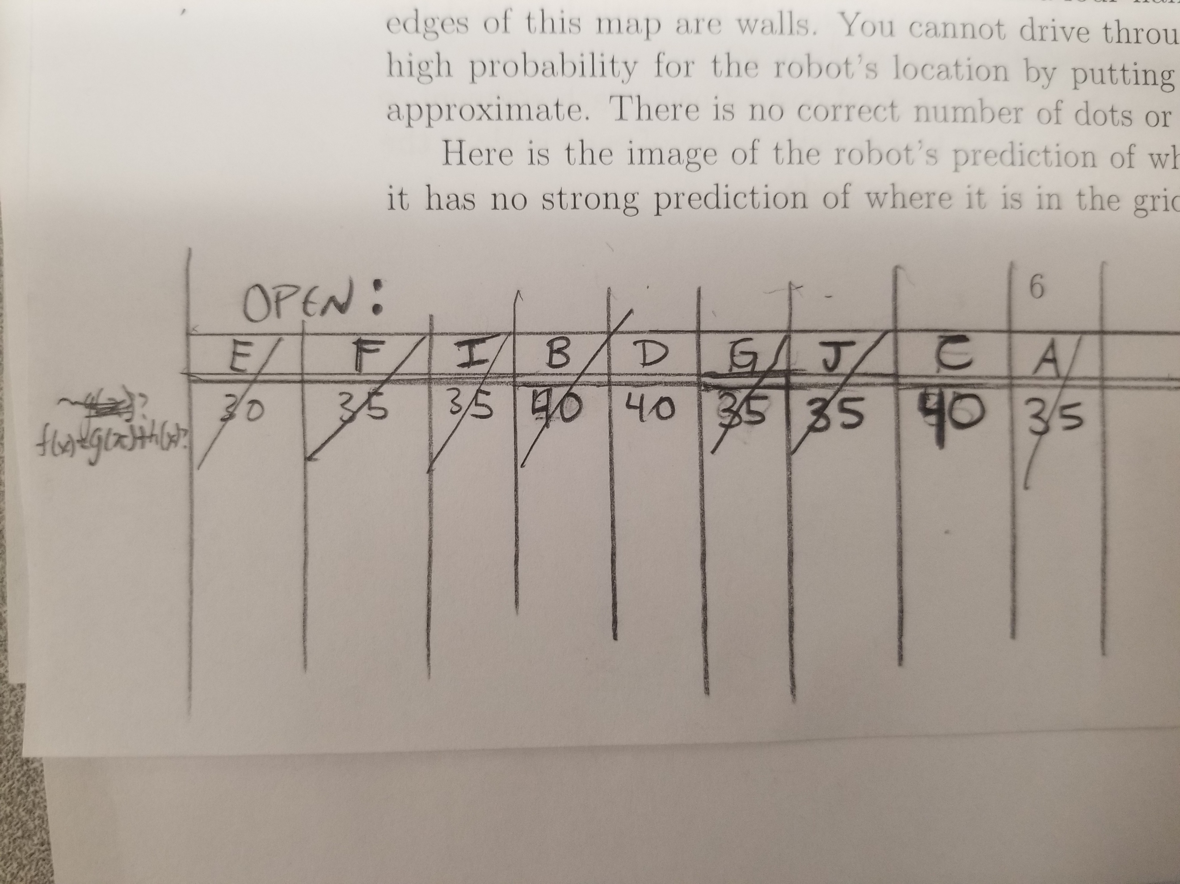

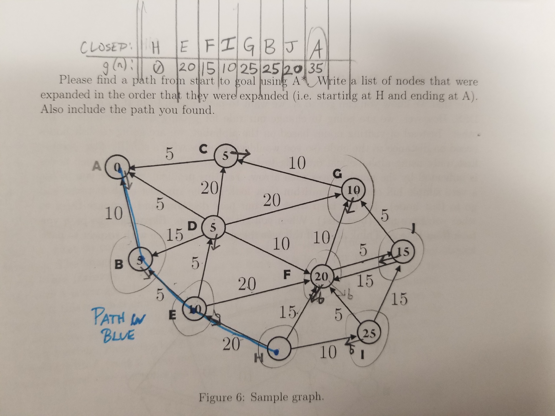

5.)

a.

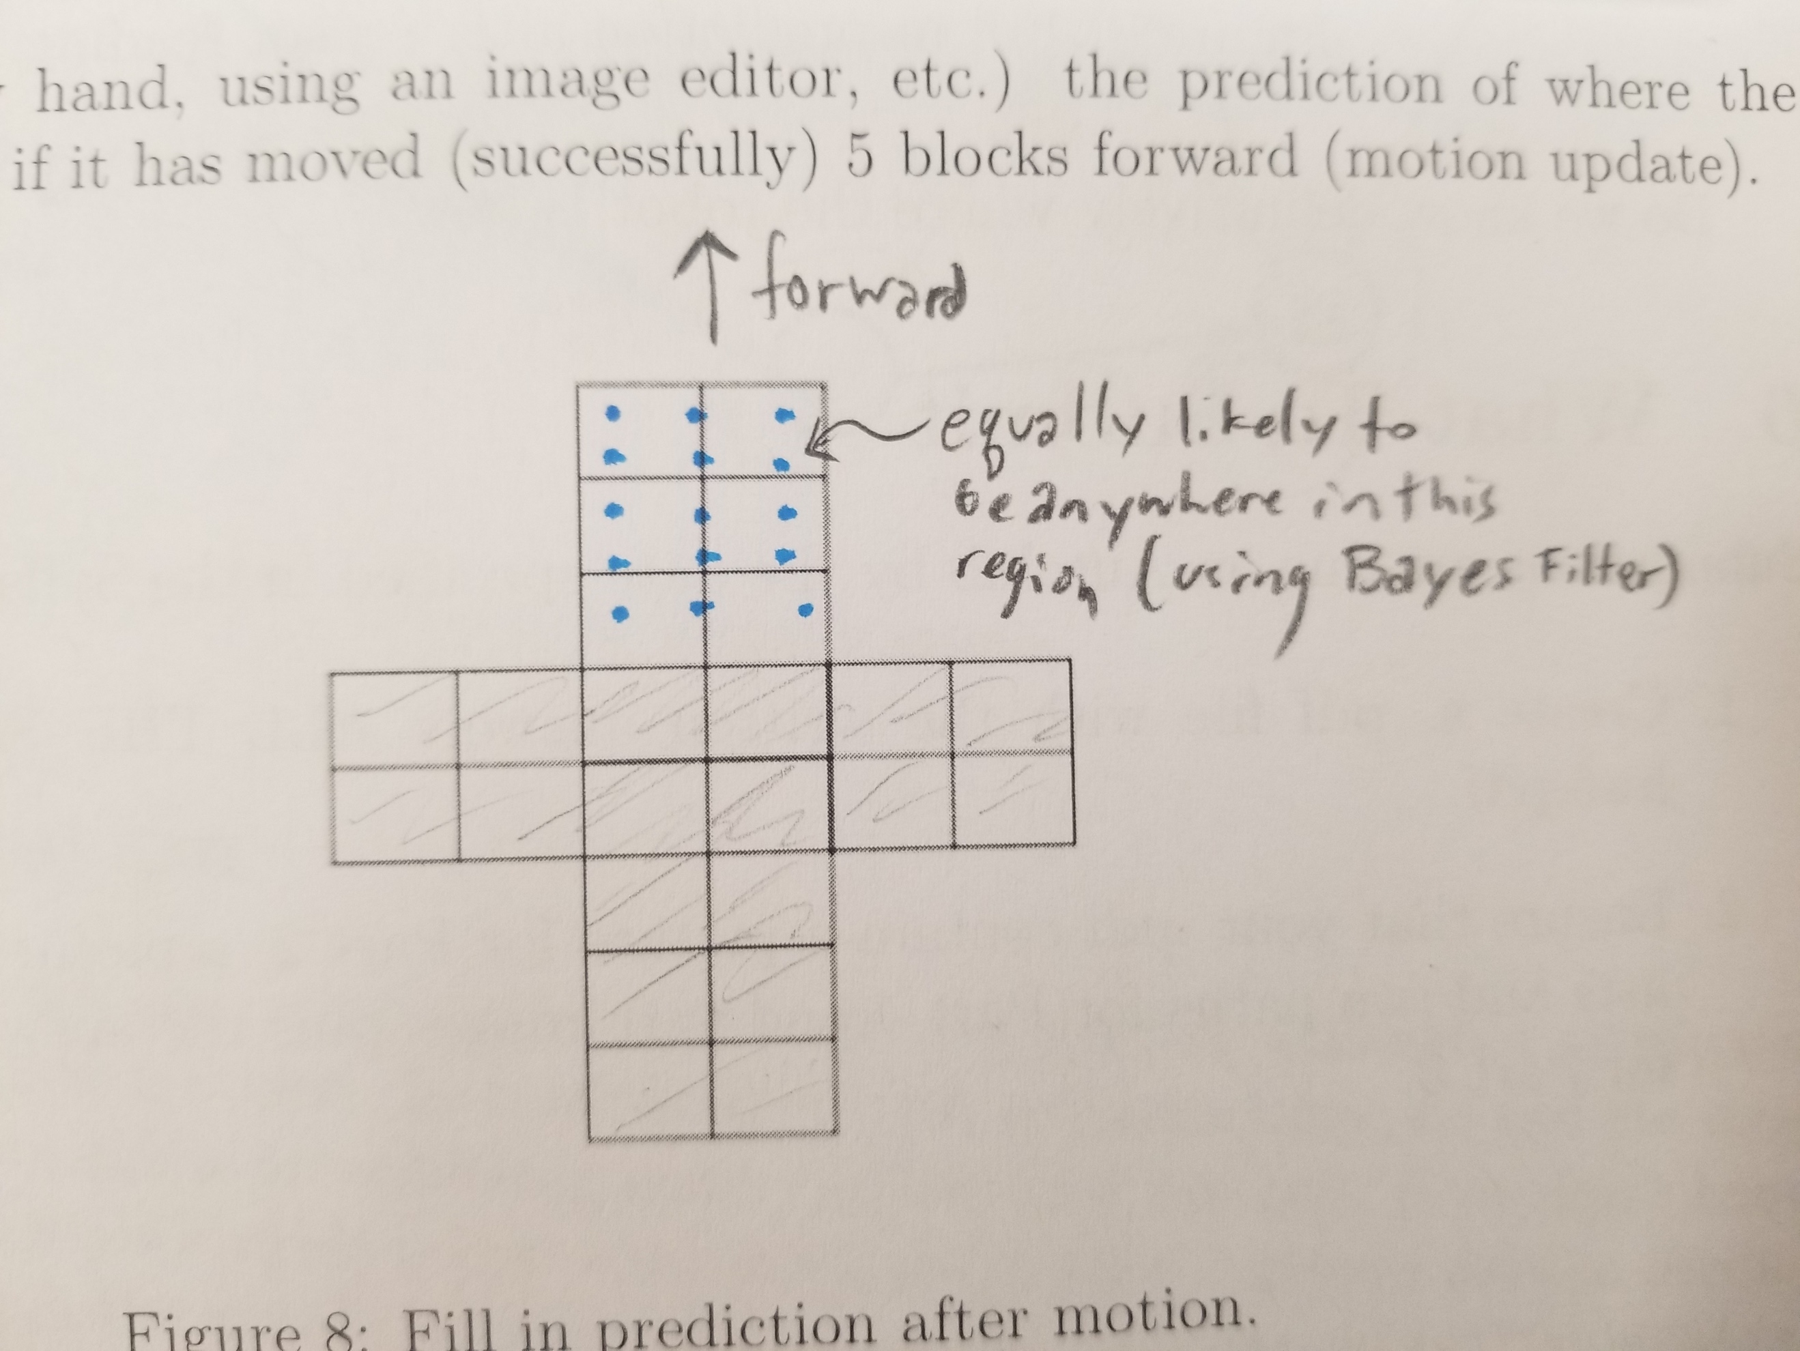

b.

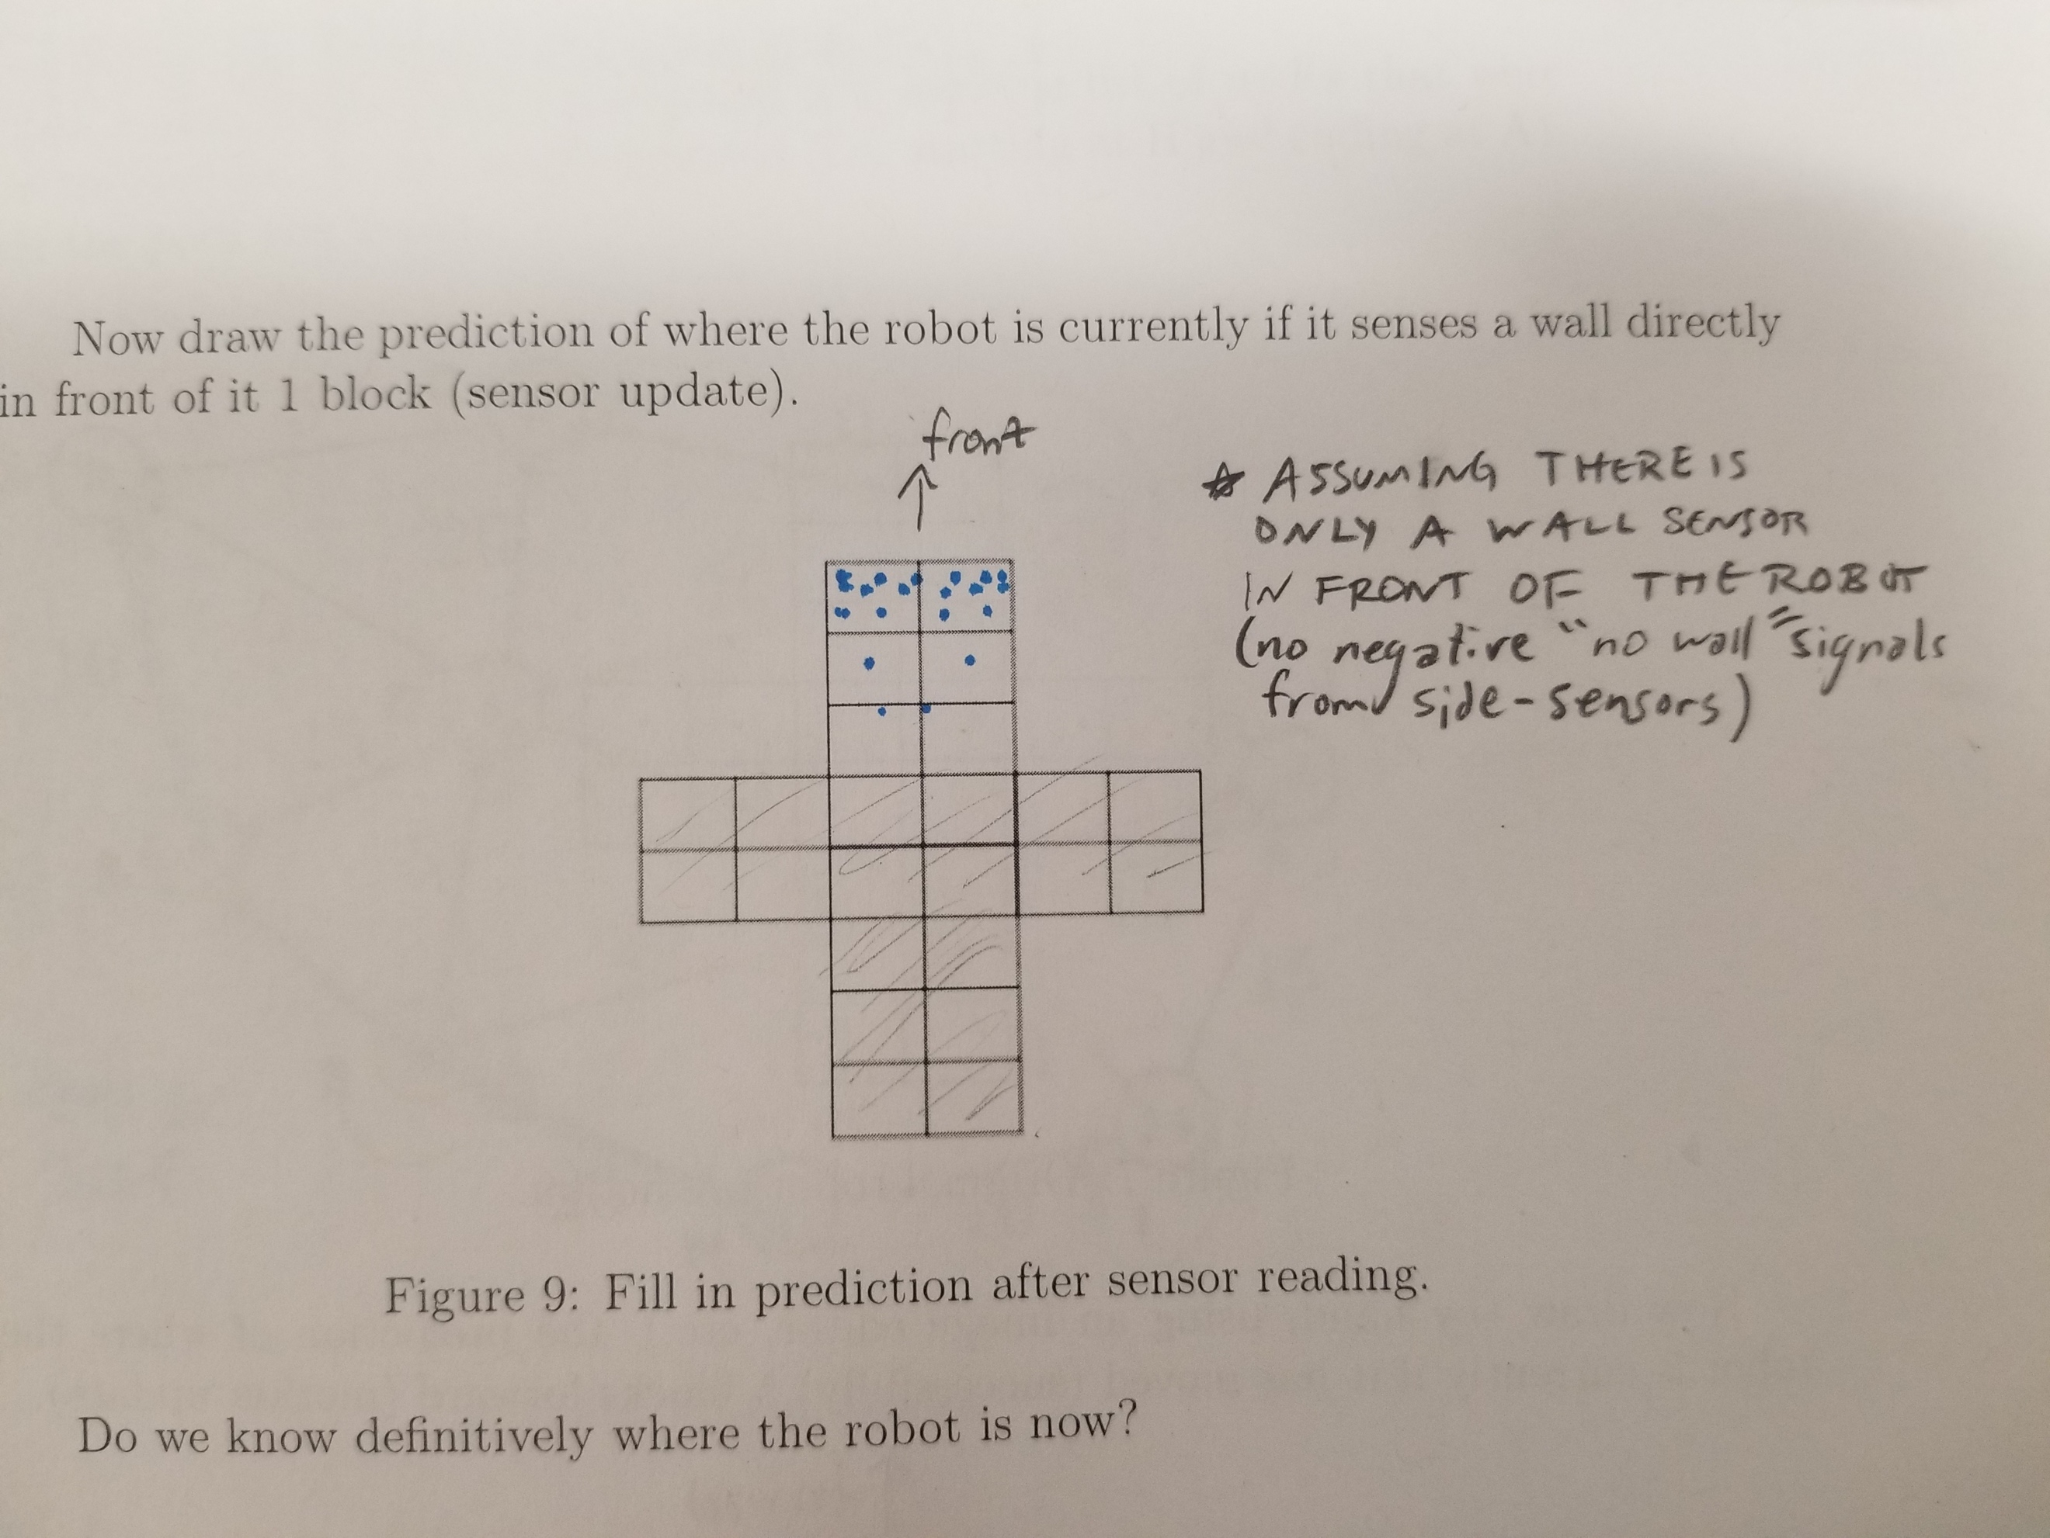

While a very good estimate of the robot’s location now exists, *it’s exact location is not definitively known* since there are many regions with non-zero (and non-effectively zero) probabilities and even a series of lateral positions near the detected wall with equally high-probabilities (assuming there aren’t side sensors not detecting the presence of a wall).